CSA1509-Cloud computing and big data analytics
Experiment-10
Create a simple cloud software application to run a c program to display the learner information using any Cloud Service Provider to demonstrate SaaS with the template of learner name, reg no, address, phone, age, courses, grades and attendance report, progress report, Semester mark sheet forms
Input:
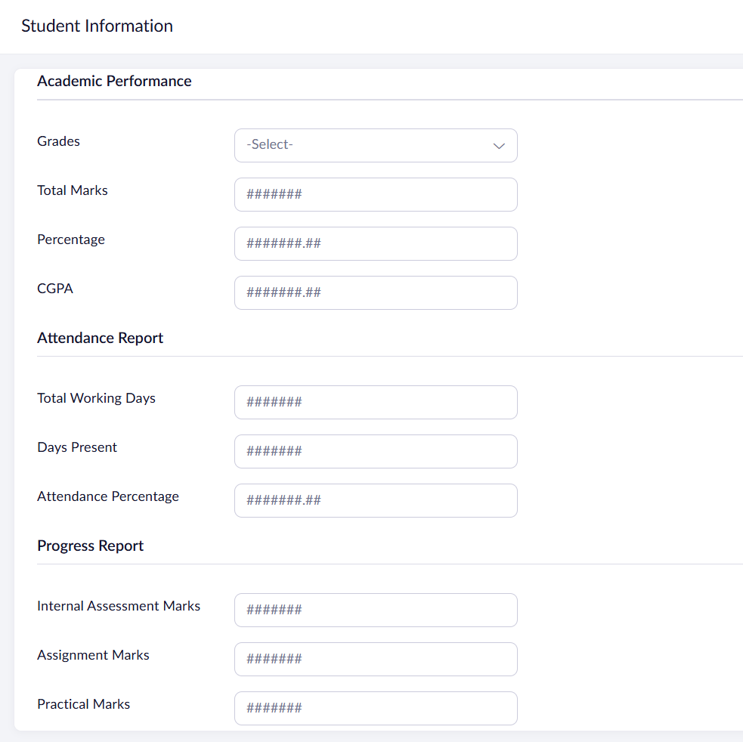
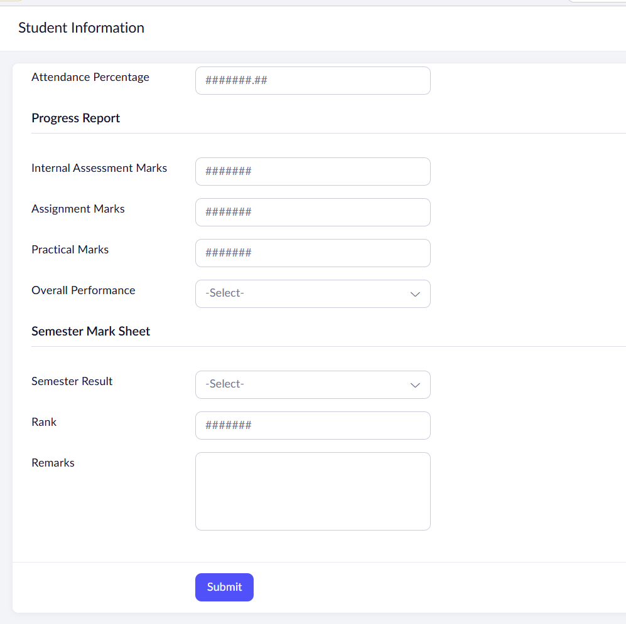
Output:
